**NETWORKING DEVICES**

Networking devices are equipments that process the packet flow through the network and make decisions regarding packet forwarding.

Hub is one of the earliest network devices. A hub is an unintelligent device. It consists of a single collision and broadcast domain. It can be used to connect multiple devices together in a layer 2 domain.

The icon representing a hub is given below

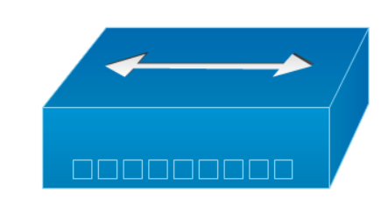

Switch is the intelligent version of a hub. It is also used to connect multiple devices in a layer 2 network. However, it separates the collision domain, creating a separate one for each port. By default, it has a single broadcast domain. However, using the concept of VLANs, you can create multiple broadcast domains. It stores the mac address table which stores information contains entries which map each mac address to a port from which it was learnt.

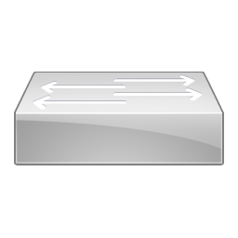

Router is a layer 3 device. It connects different networks and make decisions regarding packet routing. It divides both collision and broadcast domains. It stores the ARP table which contains entries regarding the IP addresses and the mac address associated with it.

The icon representing a router is given below.

There is another major network device called firewall. It is a security device, used for filtering packets. Security zones can be created with this device and rules can be put in place regarding what traffic should be allowed into these zones.

